Endpoints:

VIDEOLINK: https://drive.google.com/file/d/1Oh8Cd0jIfHzouhd7gwGlSL9VuAKSs6H8/view

Backend API Endpoints:

POST url

Login- <http://localhost:8083/api/auth/login>

Register- http://localhost:8083/api/auth/register

Doctor- <http://localhost:8083/api/doctors/saveDoctor>

Patient- <http://localhost:8083/api/patients/savePatient>

Appointments- <http://localhost:8083/api/appointments/saveApp>

Medications- http://localhost:8083/api/medications/saveMed

GET url:

Doctor- http://localhost:8083/api/doctors/{docId}

Bookings-[http://localhost:8083/api/bookings/{bookId}](http://localhost:8083/api/bookings/%7bbookId%7d)

Patient-http://localhost:8083/api/patients/{patId}

Medications-http://localhost:8083/api/medications/{medId}

GETAll url:

<http://localhost:8083/api/doctors>

<http://localhost:8083/api/bookings>

<http://localhost:8083/api/patients>

<http://localhost:8083/api/appointments>

<http://localhost:8083/api/medications>

GET booking by Patient Id:

[http://localhost:8083/api/bookings/patId/{patId}](http://localhost:8083/api/bookings/patId/%7bpatId%7d)

ex. http://localhost:8083/api/bookings/patId/1

PUT Mapping:

[http://localhost:8083/api/appointments/{appId}](http://localhost:8083/api/appointments/%7bappId%7d)

[http://localhost:8083/api/doctors/{docId}](http://localhost:8083/api/doctors/%7bdocId%7d)

[http://localhost:8083/api/patients/{patId}](http://localhost:8083/api/patients/%7bpatId%7d)

[http://localhost:8083/api/medications/{medId}](http://localhost:8083/api/medications/%7bmedId%7d)

DELETE Mapping:

[http://localhost:8083/api/appointments/{appId}](http://localhost:8083/api/appointments/%7bappId%7d)

[http://localhost:8083/api/doctors/{docId}](http://localhost:8083/api/doctors/%7bdocId%7d)

[http://localhost:8083/api/patients/{patId}](http://localhost:8083/api/patients/%7bpatId%7d)

[http://localhost:8083/api/medications/{medId}](http://localhost:8083/api/medications/%7bmedId%7d)

FRONT ENDPOINTS:

Appointment:

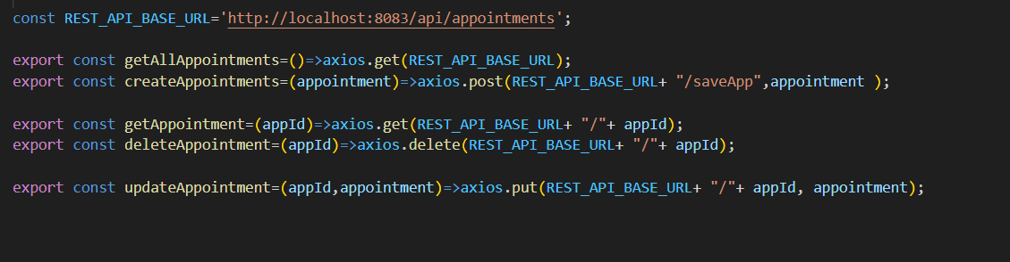

Doctor:

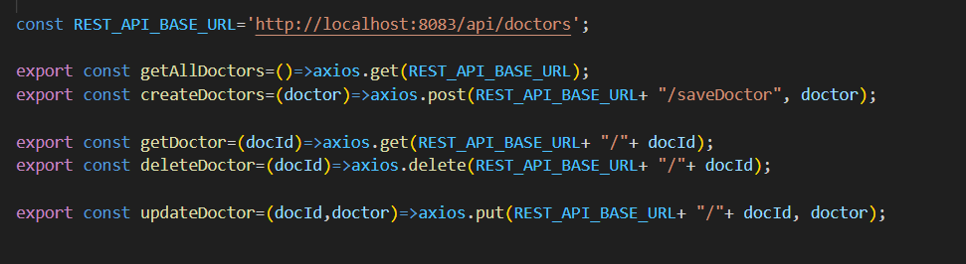

Patient:

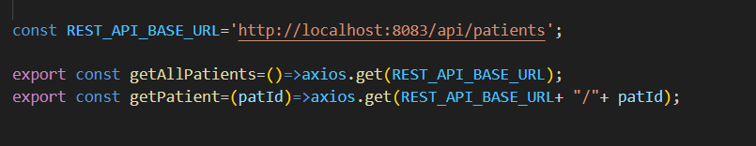

Medication:

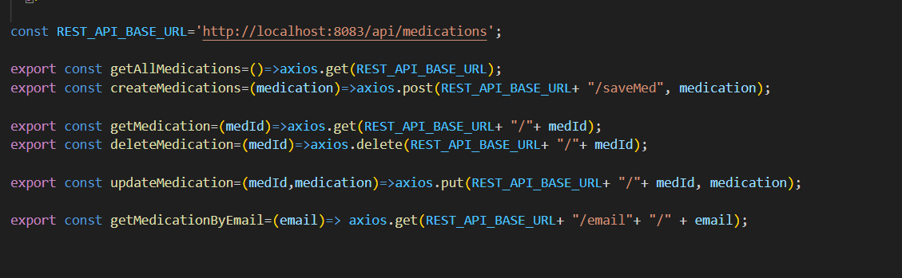

Form Validation Rules:

Register:

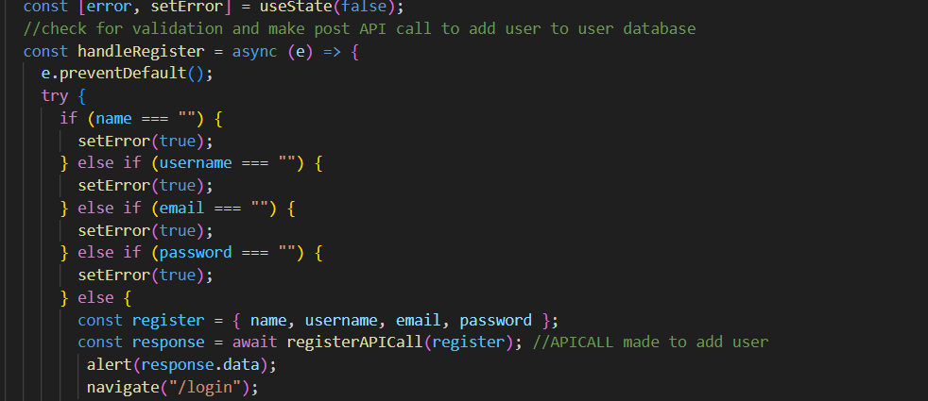

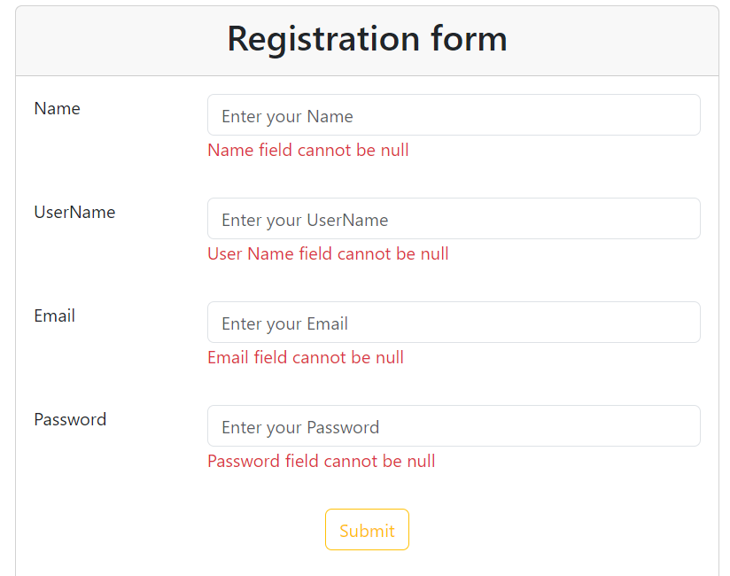

Doctor:

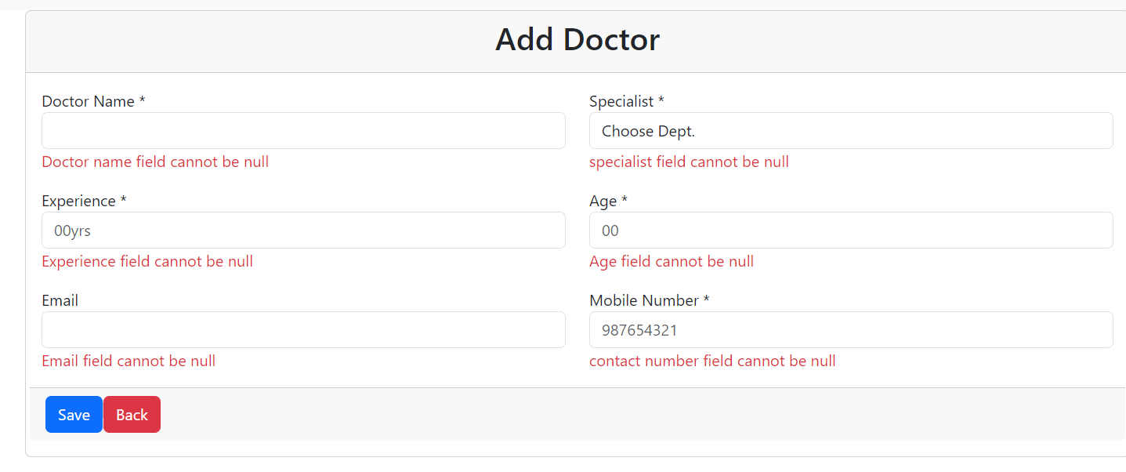

Booking:

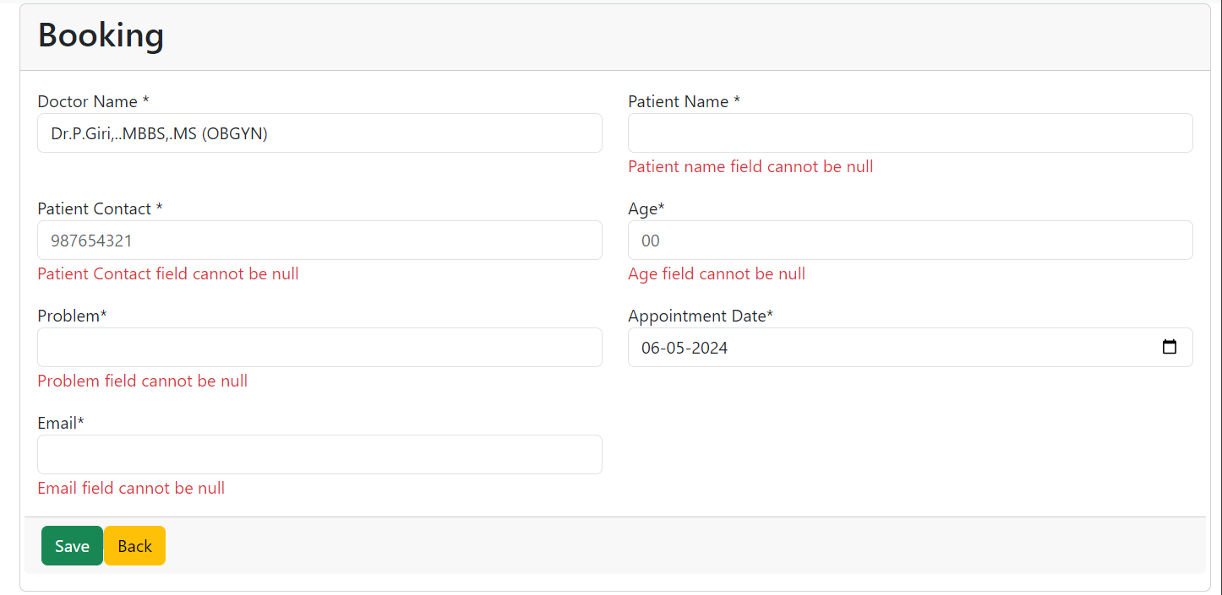

THANK YOU!